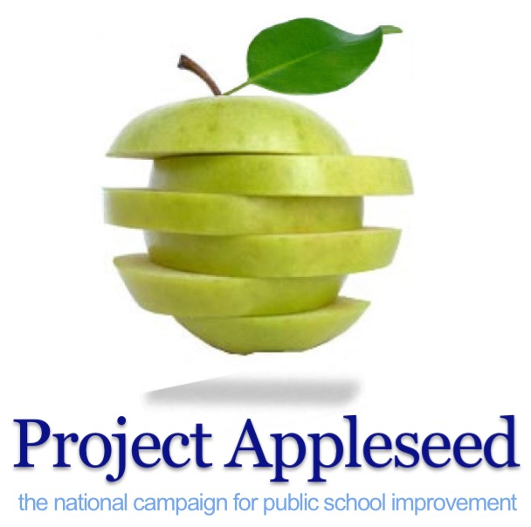
The Six Slices of
Parental Involvementtm

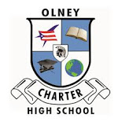

Olney Charter High School
Proclamation & Certificates for School and Parents

Proclamation
Olney Charter High School
National Parental Involvement Day
Public School Volunteer Week

Whereas, Parent and community involvement is a significant factor in the success of
schools; and

Whereas, During the past decade, school systems throughout the country have accepted the services of dedicated volunteers to assist professional educators, and these volunteers have offered their time, encouragement, and meaningful contact with students; and

Whereas, By becoming a volunteer, parents and community members are providing an invaluable contribution to the education of our students; and

Whereas, Volunteers are called upon to assist teachers and staff with the day-to-day activities involved in providing a balanced education for our students and are an important part of a team that strives to ensure that each and every one of our students succeeds; and

Whereas, During the school year, approximately, volunteers are spending hours serving Olney Charter High School as chaperones, mentors, after-school tutors, club leaders, booster club members, PTA/PTO members, guest speakers, classroom helpers, and in countless other ways;

Be It Therefore Resolved, That the Board of Education does hereby proclaim Project Appleseed’s National Parental Involvement Day and Public School Volunteer Week in Olney Charter High School and sincerely appreciates our dedicated volunteers for sharing their time and talents with the children in our community.

Signed

Title I Certification of Parental Involvement
Olney Charter High School
Section 1116 of the Every Student Succeeds Act of 2015

As a component of the school-level parental involvement policy developed under Title I, Olney Charter High School has been provided with Project Appleseed’s school-parent compact, the Parental Involvement Pledge. The Pledge outlines how parents will share the responsibility for improved student achievement and the means by which the school and parents will build and develop a partnership to help children achieve the State’s high standards. Parent engagement through the use of the Parental Involvement Pledge and the Parental Involvement Report Card, satisfies the parental involvement mandates under Title I, Section 1116 of the Every Student Succeeds Act 2015, subsection D. Olney Charter High School has demonstrated Title I parental involvement compliance under the law:

(d) SHARED RESPONSIBILITIES FOR HIGH STUDENT ACADEMIC ACHIEVEMENT- As a component of the school-level parental involvement policy developed under subsection (b), each school served under this part shall jointly develop with parents for all children served under this part a school-parent compact that outlines how parents, the entire school staff, and students will share the responsibility for improved student academic achievement and the means by which the school and parents will build and develop a partnership to help children achieve the State's high standards. Such compact shall —
(1) describe the school's responsibility to provide high-quality curriculum and instruction in a supportive and effective learning environment that enables the children served under this part to meet the State's student academic achievement standards, and the ways in which each parent will be responsible for supporting their children's learning, such as monitoring attendance, homework completion, and television watching; volunteering in their child's classroom; and participating, as appropriate, in decisions relating to the education of their children and positive use of extracurricular time; and
(2) address the importance of communication between teachers and parents on an ongoing basis through, at a minimum —

- Employing the Parental Involvement Pledge and Report Card at parent-teacher conferences in elementary schools, at least annually, during which the compact shall be discussed as the compact relates to the individual child's achievement;

- frequent reports to parents on their children's progress; and

- reasonable access to staff, opportunities to volunteer and participate in their child's class, and observation of classroom activities.

Olney Charter High School has demonstrated Title I parental involvement compliance under the law.

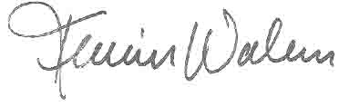Signed,

President & National Director

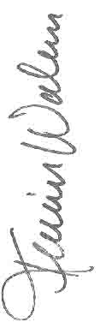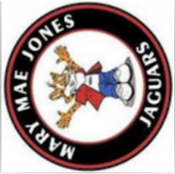
Copyright 2018 Project Appleseed, National Campaign for Public School Improvement. All rights reserved.
Project Appleseed, Parental Involvement Pledge, National Parental Involvement Day and Public School Volunteer Week, are either registered trademarks or trademarks of Project Appleseed in the United States and/or other countries. www.projectappleseed.org.
Kevin S. Walker
Founder, President & National Director
Pledge
Involvement
Parental
Has Demonstrated A Unique Commitment to Parent and Family Involvement
In the Improvement of America’s Public Schools By Taking and Distributing
Olney Charter High School
Project Appleseed
The National Campaign for Public School Improvement

Certificate of Parental Involvement

the of

Member
Copyright 2018 Project Appleseed, National Campaign for Public School Improvement. All rights reserved.
Project Appleseed, Parental Involvement Pledge, National Parental Involvement Day and Public School Volunteer Week, are either registered trademarks or trademarks of Project Appleseed in the United States and/or other countries. www.projectappleseed.org.
Kevin S. Walker
Founder, President & National Director
Pledge
Involvement
Parental
Olney Charter High School
Has Demonstrated A Unique Commitment to Parent and Family Involvement
In the Improvement of America’s Public Schools By Taking
Project Appleseed
The National Campaign for Public School Improvement

Certificate of Parental Involvement

the of

Member

