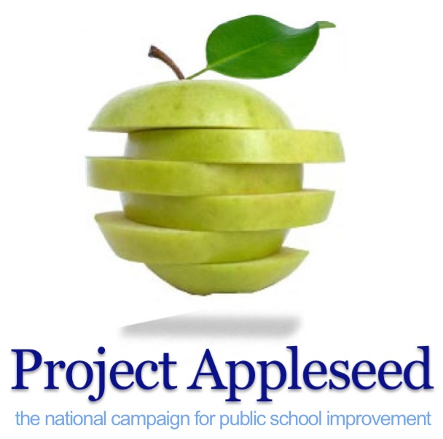
The Six Slices of
Parental Involvementtm

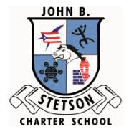

The John B. Stetson Charter School
Parental Involvement Report Card

Front and Back Master Copies Set Printer & Copier for Two-Sided Letter Paper 8 1/2
John B. Stetson Charter School
Parental Involvement Report Cardtm
The following questions are based on the Six Slices of Parental Involvement and are intended to help parents rate their contributions to their child’s success at school Research indicates that students are more successful when parents are involved in their child’s education. Use these 30 questions as a guide to discover some of the ways that you can help your child at home and at school. Simply check your answer to the following questions and then total your responses using the instructions at the end of The Report Card.

How well do you support your child’s learning?
Parenting

- Have you identified a regular time and place in your home for your child to do
his/her homework? Yes ___ No ___

- Do you monitor your child’s homework? Yes ___ No ___

- Do you monitor your child’s television viewing habits? Yes ___ No ___

- Do you ensure that your child has excellent attendance at school? Yes ___ No ___

- Have you discussed with your child the importance of a good education? Yes ___ No ___

- Did you attend Open House or Back To School Night at your child’s school? Yes ___ No ___

- Do you support and reinforce the school’s discipline plan? Yes ___ No ___

- Do you support your child’s learning by providing nutritious meals and adequate
time for sleep? Yes ___ No ___

Learning at Home

- Do you read to your young child? If your child is older, do you encourage reading by
paying attention to what your child reads, as well as how often he/she reads? Yes ___ No ___

- Do you hold your child responsible for completing all assignments on time and to the
best of his/her ability? Yes ___ No ___

- Are you knowledgeable about what information and skills your child should master at
his/her grade level or in his/her subject areas? Yes ___ No ___

How involved are you with your child’s schools?
Volunteering

- Did you sign a written Parental Involvement Pledge and volunteer to help teachers,
administrators, students and other parents? Yes ___ No ___

- Were you a class parent, telephone tree coordinator, or a volunteer who provided
parents with needed information? Yes ___ No ___

- Were you a part of parent patrols or other activities to increase the safety and operation
of your child’s school and programs? Yes ___ No ___

Copyright 2018 Project Appleseed, National Campaign for Public School Improvement. All rights reserved.
Project Appleseed, Parental Involvement Pledge, National Parental Involvement Day and Public School Volunteer Week, are either registered trademarks or trademarks of Project Appleseed in the United States and/or other countries. www.projectappleseed.org

Decision Making

- Have you attended at least one PTA, PTO or other support group meeting this year? Yes ___ No ___

- Have you worked on school-based management committees, district level councils
and/or committees on issues concerning your schools? Yes ___ No ___

- Did you assist in providing information on school or local district elections for school
representatives? Yes ___ No ___

Community Involvement

- Have you attended at least one school program? (i.e. award assembly,
play/performance, athletic event or school party?) Yes ___ No ___

- Are you a mode of “good sportsmanship” when attending school events? Yes ___ No ___

- Do you insist that your child exhibit good sportsmanship at all times? Yes ___ No ___

- Do you encourage your child to participate in volunteer projects in the community? Yes ___ No ___

How familiar are you with school information?
Communicating

- Have you read the student code of conduct and/or discipline policy? Yes ___ No ___

- Do you regularly read the school newsletter? Yes ___ No ___

- Are you familiar with the extra services provided at your child’s school? (i.e. speech
therapy, resource help for gifted students, counseling) Yes ___ No ___

- Do you make yourself available for conferences requested by your child’s teacher? Yes ___ No ___

- Have you had at least one parent teacher conference with the teacher(s) of your child? Yes ___ No ___

- Do you initiate contact with your child’s teacher or principal just to show your support? Yes ___ No ___

- Are you aware of your child’s academic strengths and weaknesses? Yes ___ No ___

- Do you ensure that your takes courses to prepare him/her for a chosen career path? Yes ___ No ___

- Are you familiar with the grading scale used on your child’s report card? Yes ___ No ___

TOTAL: Yes ___ No ___

How Did You Score?

INSTRUCTIONS:
Now go back and count the boxes checked ‘Yes’ and then add them up to get your score!

21 – 30: EXCELLENT! Congratulations! You are a strong partner in your child’s education!

10 – 20: GOOD! Yes! You are making wonderful contributions to your child’s education but there are even more ways that can help!

0 – 9: NEEDS IMPROVEMENT! Your school and child needs your help! Your child’s success at school
might be increased if you were able to help more!

